HEALTHSCOPE: AN INTELLIGENT PUBLIC HEALTH
ANALYTICS AND RISK ASSESSMENT PLATFORM
A Project Report Submitted in
the partial fulfillment of the requirements for the award of the degree of

BACHELOR OF TECHNOLOGY
In

DEPARTMENT OF CSE
By
P.Varsha | :2420030331
Harshini | :2420030113

Under the Esteemed Guidance of

Dr.N.Sunanda

Associate Professor

Department of CSE

AY-2026-27

Semester:Odd




K L (Deemed to be) University
DEPARTMENT OF CSE

Declaration

The Project Report entitled “HEALTHSCOPE: AN INTELLIGENT PUBLIC HEALTH ANALYTICS AND RISK ASSESSMENT PLATFORM” is a record of Bonafide work of Varsha-2420030331, Harshini-2420030113, submitted in partial fulfillment for the award of B. Tech in CSE to the K L University. The results embodied in this report have not been copied from any other departments/University/Institute.

Varsha-2420030331
Harshini-2420030113

K L (Deemed to be) University
DEPARTMENT OF CSE

CERTIFICATE

This is to certify that the mini project based report entitled “HEALTHSCOPE: AN INTELLIGENT PUBLIC HEALTH ANALYTICS AND RISK ASSESSMENT PLATFORM” is a bonafide work done and submitted by Varsha-2420030331, Harshini-2420030113,in partial fulfillment of the requirements for the award of the degree of BACHELOR OF TECHNOLOGY in Department of CSE, K L (Deemed to be University), during the academic year 2026-2027.

_____________________  Signature of the Guide  Dr. N. Sunanda  Associate Professor, CSE | _____________________  Course Coordinator  Dr. N. Sunanda  Department of CSE | _____________________  Head of the Department  Dr.P. Venkateswara Rao  Department of CSE

ACKNOWLEDGEMENT
The success in this project would not have been possible but for the timely help and guidance rendered by many people. Our wish to express my sincere thanks to all those who has assisted us in one way or the other for the completion of my project.

Our greatest appreciation to my Course Coordinator and my guide Dr.N.Sunanda, Department of CSE which cannot be expressed in words for her tremendous support, encouragement and guidance for this project.

We express our gratitude to P.Venkateshwara Rao, Head of the Department for CSE for providing us with adequate facilities, ways and means by which we are able to complete this project-based Lab.

We thank all the members of teaching and non-teaching staff members, and also who have assisted me directly or indirectly for successful completion of this project. Finally, I sincerely thank my parents, friends and classmates for their kind help and cooperation during my work.

Varsha-2420030331
Harshini-2420030113

Abstract
HealthScope: An Intelligent Public Health Analytics & Risk Assessment Platform is a data-driven system designed to analyze public health information and identify potential health risks within populations. The platform brings together relevant health, demographic, lifestyle, and environmental data to transform raw and complex datasets into meaningful and interpretable insights. Public health datasets often contain large volumes of information collected from different sources, making it difficult to manually identify important patterns, relationships, and risk factors. Issues such as missing values, inconsistent data formats, duplicate records, outliers, and fragmented information can further affect the quality and reliability of analysis. HealthScope aims to address these challenges by applying data science techniques to organize, process, analyze, and visualize public health data in a systematic manner.

The proposed system follows a structured data science workflow beginning with data collection and preprocessing. The collected datasets are examined for missing values, inconsistencies, duplicate records, outliers, and other data-quality issues before being prepared for further analysis. Appropriate preprocessing techniques are applied to improve the quality and usability of the data. Exploratory Data Analysis (EDA) is then performed to understand the underlying characteristics of the dataset and identify significant trends, distributions, correlations, and potential anomalies. Statistical summaries and visualizations are used to examine relationships between health, demographic, lifestyle, and environmental factors. This allows the system to identify potentially influential factors and patterns that may be difficult to recognize through manual analysis.

HealthScope incorporates analytical and machine learning techniques for risk assessment based on the available data. The system can be used to identify population groups that may have relatively higher levels of health risk and to examine the factors associated with those risks. Depending on the dataset and selected target variable, the platform can apply suitable classification or predictive models to generate data-driven risk assessments. Model performance can be evaluated using appropriate metrics such as accuracy, precision, recall, F1-score, and confusion matrices. This provides a measurable way to assess the reliability of the developed analytical approach rather than relying only on visual observations.

A major purpose of HealthScope is to make public health information easier to understand and use for data-driven decision-making. The results are presented through an interactive dashboard containing charts, graphs, statistical summaries, trends, correlations, and risk-related insights. The platform can be used to explore population-level health patterns, compare different demographic groups, identify potentially high-risk groups, examine relationships between lifestyle or environmental factors and health outcomes, and highlight areas that may require further attention. Such insights can be useful for understanding public health trends, supporting awareness and preventive planning, and assisting researchers or public health stakeholders in identifying areas for further investigation.

The system also addresses several common challenges associated with public health data analysis. These include poor data quality, incomplete records, large and complex datasets, difficulty in identifying relationships between multiple variables, and the challenge of communicating analytical results in an understandable form. By combining data preprocessing, exploratory data analysis, visualization, and risk assessment within a single platform, HealthScope provides an end-to-end data science workflow for converting raw public health data into accessible insights. The dashboard-oriented approach also reduces the difficulty of interpreting complex statistical information by presenting important findings visually and interactively.

Index
S. No. | Chapters | Topics | Page.no
 |  | Acknowledgement
 |  | Abstract
1 | Introduction | 1.1 Background of the project  1.2 Problem statement  1.3 Scope of the project  1.4 Objective(s)  1.5 Importance of the application  1.6 Target users/audience | 1-10
2 | System Requirements | 2.1 Hardware requirements  2.2 Software requirements  2.3 Development tools and frameworks | 11-20
3 | Technology Stack | 3.1 Front-end (e.g., React.js, Angular, HTML/CSS)  3.2 Back-end (e.g., Node.js, Django, Spring Boot)  3.3 Database (e.g., MongoDB, MySQL, PostgreSQL)  3.4 Version Control (e.g., Git, GitHub)  3.5 APIs or External services (e.g., Firebase, Stripe) | 21-30
4 | System Architecture | 4.1 High-level architecture diagram  4.2 Description of each layer (frontend, backend, database)  4.3 Deployment architecture (e.g., cloud, local, CI/CD pipelines) | 31-35
5 | Design | 5.1 Wireframes or mockups  5.2 ER Diagram / Database schema | 36-42
6 | Implementation | 6.1 Module-wise implementation  6.2 Front-end logic (UI rendering, state management)  6.3 Backend logic (routes, controllers, business logic)  6.4 Database connectivity  6.5 API integration  6.6 Authentication & Authorization | 43-55
7 | Features | 7.1 List of main features  7.2 How each feature works (user perspective + technical description) | 56-60
8 | Testing | 8.1 Postman testing (frontend/backend)  8.2 Integration testing  8.3 Tools used for testing  8.4 Test cases and results | 61-67
9 | Deployment | 9.1 Steps to deploy  9.2 Environment configuration  9.3 Hosting of frontend and backend | 68-73
10 | Challenges & Limitations | 10.1 Issues faced during development  10.2 Solutions applied  10.3 Current limitations or known bugs | 74-80
11 | Future Enhancements | 11.1 Planned features  11.2 Possible integrations or optimizations | 81-88
12 | Conclusion | 12.1 Summary of the project  12.2 What was achieved  12.3 Skills learned during development | 89-100
13 | References | - Books, tutorials, APIs, documentation sites used
14 | Appendices | - Screenshots of the app  - Sample code snippets  - Installation/setup instructions  - User manual or guide  -certifications

CHAPTER 1
Introduction

  - Problem Statement
Public health data contains valuable information about diseases, health conditions, and population health trends. However, this information is often scattered across different datasets and is difficult to understand without proper data cleaning, analysis, and visualization. Identifying health patterns, comparing population groups, and understanding relationships between health indicators becomes challenging for non-technical users.
Therefore, there is a need for an integrated platform that collects, preprocesses, analyses, and visualizes public health data. The proposed HealthScope platform aims to simplify population-level health analysis using statistical techniques, data analytics, and suitable machine learning models to provide meaningful insights and support informed public-health decisions.

1.2 Motivation
- Public health datasets contain valuable information about diseases, health conditions and population health trends.
- However, raw health data can be difficult to understand without proper analysis and visualization.
- There is a need for a simple platform that helps users identify health patterns, compare regions and understand relationships between health indicators.
- HealthScope aims to make public health information more accessible through data analytics, statistical techniques and interactive dashboards.
- It can support students, researchers and public-health stakeholders in making better-informed decisions.

1.3 Objectives

- To collect and integrate relevant public health, demographic, lifestyle, and environmental datasets for population-level analysis.
- To preprocess and clean public health data by handling missing values, duplicate records, inconsistent data, outliers, and other data-quality issues.
- To perform Exploratory Data Analysis (EDA) to understand the distribution, trends, patterns, and characteristics of public health data.
- To identify relationships and correlations between health-related factors such as demographic, lifestyle, and environmental variables and selected health outcomes.
- To identify potentially high-risk population groups based on the patterns and factors observed in the data.
- To develop a data-driven risk assessment model using suitable statistical and machine learning techniques to estimate potential health-risk categories.
- To evaluate the performance of the developed model using appropriate metrics such as accuracy, precision, recall, F1-score, and confusion matrix.
- To visualize public health trends and analytical findings using meaningful charts, graphs, statistical summaries, and interactive visualizations.
- To develop an interactive dashboard that presents health trends, risk factors, correlations, and risk-assessment results in an accessible format.
- To provide data-driven insights that can support public health awareness, preventive planning, and further investigation, while ensuring that the platform functions as an analytical aid rather than a medical diagnostic system.

CHAPTER 2
LITERATURE SURVEY
S.No. | Author / Year | Method / System | Key Findings | Limitations
1 | Abhadiomhen et al. (2024) | Reviewed machine learning approaches for health-risk assessment. | Reviewed 231 studies and highlighted reporting and validation concerns. | Mainly focuses on health-risk assessment methods.
2 | Chandran & Roy (2024) | Reviewed GIS and spatial analysis in Indian health research. | Helps compare health indicators across different geographical regions. | Mainly focuses on geographical analysis.
3 | McClymont et al. (2024) | Reviewed AI-based infectious disease surveillance and early-warning systems. | Explains methods for identifying disease trends and local health conditions. | Focuses mainly on infectious disease surveillance.
4 | Cuevas-Chávez et al. (2023) | Reviewed ML and IoT approaches for cardiovascular disease prediction. | Highlights the use of ML in disease prediction and monitoring. | Mainly focuses on cardiovascular diseases.
5 | Rabiei et al. (2024) | Reviewed public health surveillance dashboard design principles. | Identified important dashboard features for health monitoring and decision-making. | Focuses mainly on dashboard design.
6 | Schulze et al. (2023) | Reviewed digital dashboards for public health data visualization. | Explained how dashboards help communicate health information and disease trends. | Limited evaluation of user requirements and usability.
7 | Kim et al. (2024) | Reviewed spatial-temporal epidemiological data visualization techniques. | Identified visualization methods for analysing geographical and time-based disease patterns. | Focuses mainly on epidemiological visualization.
8 | Wiemken & Kelley (2020) | Reviewed machine learning in epidemiology and health outcomes research. | Explained how ML techniques can support epidemiological research and health outcome analysis. | Focuses primarily on machine learning applications.
9 | Birdi et al. (2024) | Reviewed bias in machine learning applications for population-level non-communicable diseases. | Highlighted the importance of identifying and addressing bias in ML models. | Concentrates on non-communicable diseases.
10 | Islam et al. (2025) | Reviewed AI-based public health surveillance and real-time data analytics. | Explained how AI and ML can support disease monitoring and prediction. | Highlights challenges in data standardization, privacy and infrastructure.

Research Gap
Existing studies focus on specific areas such as disease prediction, geographical analysis and disease surveillance. HealthScope aims to integrate data collection, preprocessing, statistical analysis, relationship identification and visualization into a single platform for better understanding of public health trends.

CHAPTER 3
Software Requirement

Hardware Requirements
- Processor: Intel Core i3 or above
- RAM: Minimum 4 GB (8 GB recommended)
- Storage: Minimum 10 GB free space
- System: Desktop or laptop
- Internet connection for accessing public health datasets
Software Requirements
- Operating System: Windows 10/11
- Programming Language: Python
- IDE: VS Code / Jupyter Notebook
- Libraries: Pandas, NumPy, Scikit-learn, SciPy, Statsmodels
- Data Visualization: Matplotlib, Plotly
- Dashboard Development: Streamlit
- Dataset Source: CDC PLACES / WHO Global Health Observatory

CHAPTER 4
PROPOSED METHODOLOGY AND SYSTEM ARCHITECTURE
4.1 Proposed Methodology
The proposed HealthScope system follows an integrated approach to collect, process, analyse, and visualize public health data. It uses Python-based data analysis, statistical techniques, and suitable machine learning algorithms to identify health patterns and relationships among different health indicators.
The methodology consists of the following stages:
1. Data Collection
Public health datasets are collected from reliable sources such as WHO, CDC, and other open-data platforms. These datasets contain information about diseases, health indicators, population groups, and geographical regions.
2. Data Preprocessing
The collected datasets are examined and cleaned to improve data quality. This stage includes:
- Handling missing values.
- Removing duplicate records.
- Identifying invalid entries.
- Correcting inconsistent data formats.
- Converting data into suitable formats for analysis.
3. Exploratory Data Analysis (EDA)
Exploratory Data Analysis is performed to understand the characteristics of the dataset. Statistical summaries and visualizations are used to identify patterns, distributions, variations, and trends in public health indicators.
4. Statistical Analysis
Statistical techniques such as descriptive statistics, Pearson correlation, and Spearman correlation are applied to identify relationships between different health indicators.
5. Machine Learning Model Development
Suitable machine learning algorithms such as Logistic Regression, Decision Tree, and Random Forest are considered for classification tasks. Regression techniques may also be used when the dataset contains appropriate continuous target variables.
The models are trained and evaluated using suitable validation techniques.
6. Dashboard Development
An interactive dashboard is developed using Streamlit and Plotly. It presents health statistics, graphical representations, comparisons, correlations, and model outputs where available.
7. Testing and Evaluation
The system is tested to verify dataset loading, preprocessing, dashboard functionality, and model performance. Appropriate evaluation metrics such as accuracy, precision, recall, and F1-score are used for classification models.

4.2 System Architecture
HealthScope follows a modular architecture consisting of different interconnected components. Each component performs a specific function and passes its output to the next stage.
Architecture Components
1. Data Source Layer
This layer collects public health datasets from reliable sources such as WHO, CDC, and other open-data repositories.
2. Data Preprocessing Layer
This layer cleans and transforms the collected datasets by handling missing values, duplicates, inconsistent formats, and invalid records.
3. Data Analysis Layer
This layer performs exploratory data analysis, statistical calculations, correlation analysis, and identification of health trends.
4. Machine Learning Layer
This layer applies suitable machine learning algorithms to identify patterns and perform risk classification or prediction when the available dataset supports it.
5. Visualization Layer
This layer presents the analytical results through interactive charts, graphs, comparisons, and dashboards using Streamlit and Plotly.
6. User Interface Layer
Users can interact with the dashboard, explore health indicators, apply filters, and understand population-level health insights.

4.3 Algorithms Used
The following algorithms and techniques are considered in the HealthScope platform.
Algorithm / Technique | Purpose
Descriptive Statistics | Summarizes health data using mean, median, mode and standard deviation.
Pearson Correlation | Identifies linear relationships between numerical health indicators.
Spearman Correlation | Identifies monotonic relationships between variables.
Logistic Regression | Performs classification tasks.
Decision Tree | Classifies data using decision-based rules.
Random Forest | Uses multiple decision trees to improve classification performance.

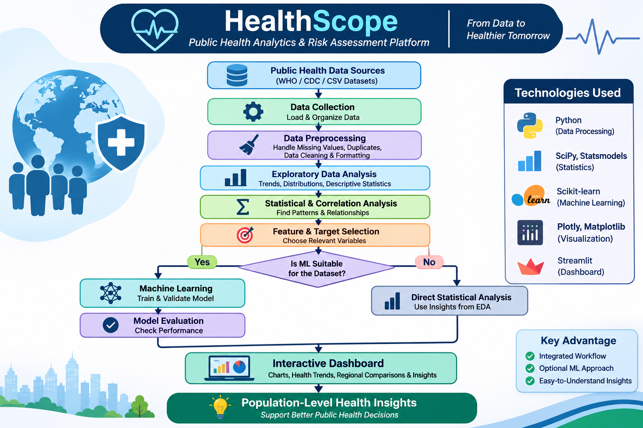

CHAPTER 4
FEATURES AND FUNCTIONALITIES
HealthScope is an intelligent public health analytics and risk assessment platform designed to simplify the analysis of public health datasets. It provides various features to collect, process, analyse, and visualize health information through an interactive dashboard.
4.1 Key Features
1. Public Health Data Collection
- Collects datasets from reliable sources such as WHO and CDC.
- Supports loading public health datasets for analysis.
- Identifies relevant health indicators and attributes.
2. Automated Data Preprocessing
- Identifies missing and duplicate values.
- Handles inconsistent data formats.
- Removes invalid records.
- Prepares clean datasets for analysis.
3. Exploratory Data Analysis (EDA)
- Provides statistical summaries of health datasets.
- Identifies patterns, distributions, and variations.
- Helps understand health trends across population groups.
4. Statistical Analysis
- Calculates mean, median, mode, and standard deviation.
- Uses Pearson and Spearman correlation.
- Identifies relationships between different health indicators.
5. Machine Learning-Based Risk Assessment
- Supports suitable machine learning algorithms such as Logistic Regression, Decision Tree, and Random Forest.
- Performs classification and prediction when appropriate data is available.
- Evaluates model performance using accuracy, precision, recall, and F1-score.
6. Interactive Data Visualization
- Displays health information through charts, graphs, and tables.
- Provides interactive filters for exploring datasets.
- Supports geographical and population-group comparisons where data permits.
7. Health Analytics Dashboard
- Provides a centralized interface for exploring public health information.
- Displays dataset summaries, health trends, statistical results, and model outputs.
- Makes complex health information easier to understand.
4.2 Functionalities
S.No. | Functionality | Description
1 | Dataset Upload | Allows users to load public health datasets.
2 | Data Validation | Checks dataset quality and consistency.
3 | Data Cleaning | Handles missing values, duplicates, and invalid records.
4 | Statistical Analysis | Calculates statistical measures and correlations.
5 | Trend Analysis | Identifies patterns and variations in health indicators.
6 | Risk Assessment | Applies suitable ML models for risk classification when supported by data.
7 | Data Visualization | Generates charts, graphs, and comparisons.
8 | Dashboard Interaction | Allows users to explore results using interactive filters.
9 | Model Evaluation | Evaluates predictive models using appropriate performance metrics.
10 | Health Insights | Presents meaningful population-level health information.
4.3 User Benefits
- Simplifies public health data analysis.
- Reduces the effort required for manual data processing.
- Helps identify important health patterns and relationships.
- Supports researchers and students in understanding health trends.
- Provides an interactive and accessible analytical platform.
- Supports informed public-health research and planning.

CHAPTER 5
Results

The HealthScope project aims to provide an integrated platform for analysing public health datasets and identifying meaningful health patterns. The proposed system combines data preprocessing, exploratory data analysis, statistical techniques, machine learning, and interactive visualization.
5.1 Expected Results
- Data Collection: Public health datasets are collected from reliable sources and loaded into the system for analysis.
- Data Preprocessing: Missing values, duplicate records, and inconsistent entries are identified and handled to improve data quality.
- Exploratory Data Analysis: Statistical summaries and visualizations help identify distributions, variations, and trends in health indicators.
- Statistical Analysis: Correlation techniques help identify relationships between different health indicators.
- Machine Learning Analysis: Suitable ML algorithms, such as Random Forest, Decision Tree, and Logistic Regression, can be evaluated for classification tasks when the dataset supports prediction.
- Dashboard Visualization: The interactive dashboard presents health statistics, comparisons, trends, and analytical outputs in an understandable format.

5.4 Discussion
HealthScope provides a proposed unified workflow for public health data analysis. By combining data preprocessing, statistical analysis, and visualization, the platform aims to make complex health datasets easier to understand.
The dashboard is intended to help students, researchers, and public-health stakeholders explore health patterns and compare different population groups. Machine learning can further support risk assessment when suitable data and prediction targets are available.

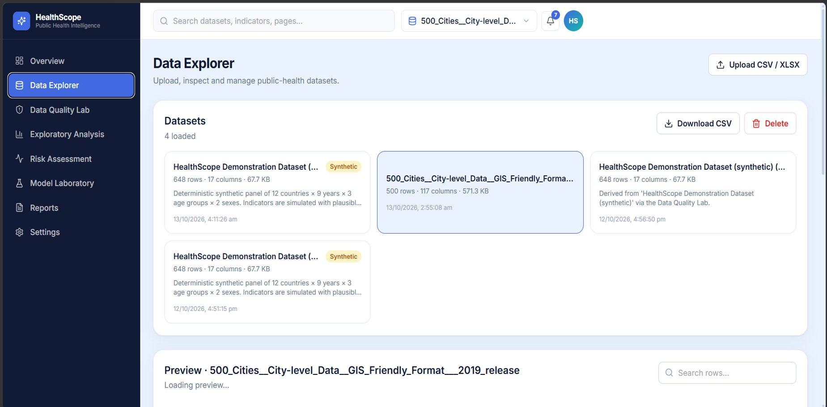

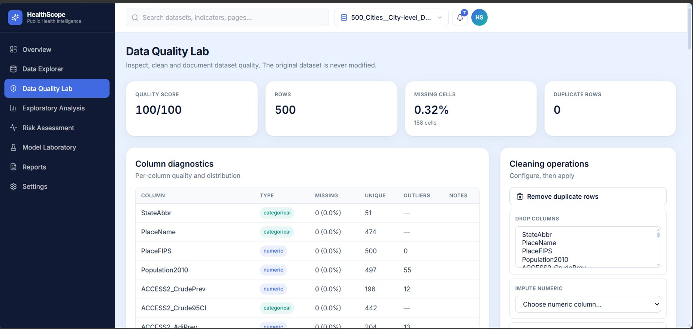

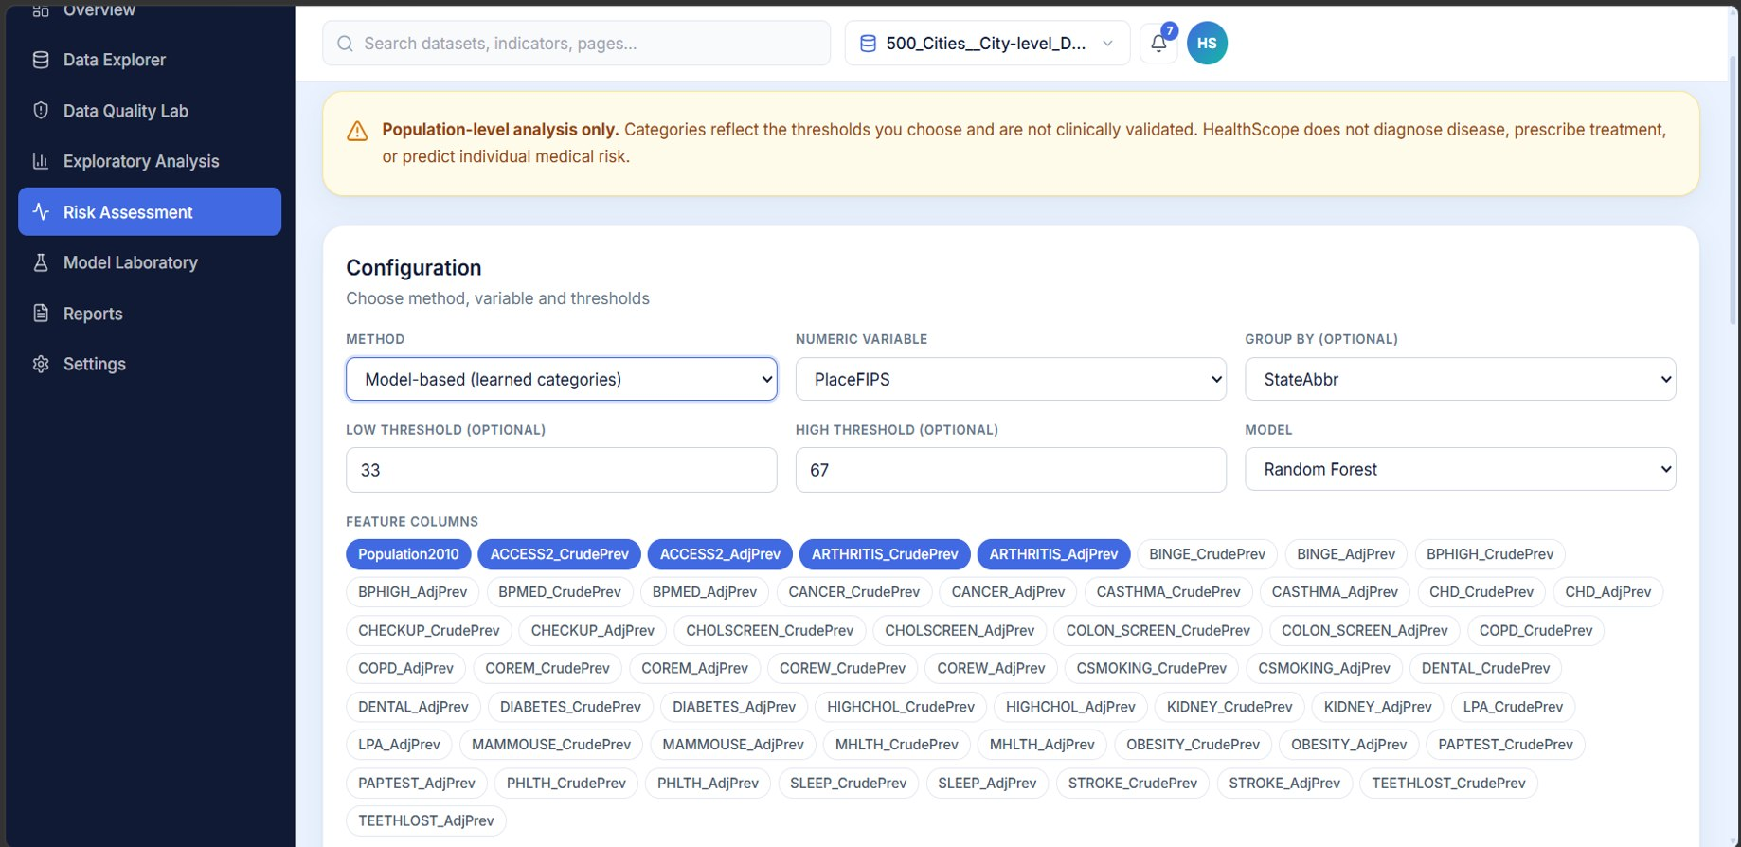
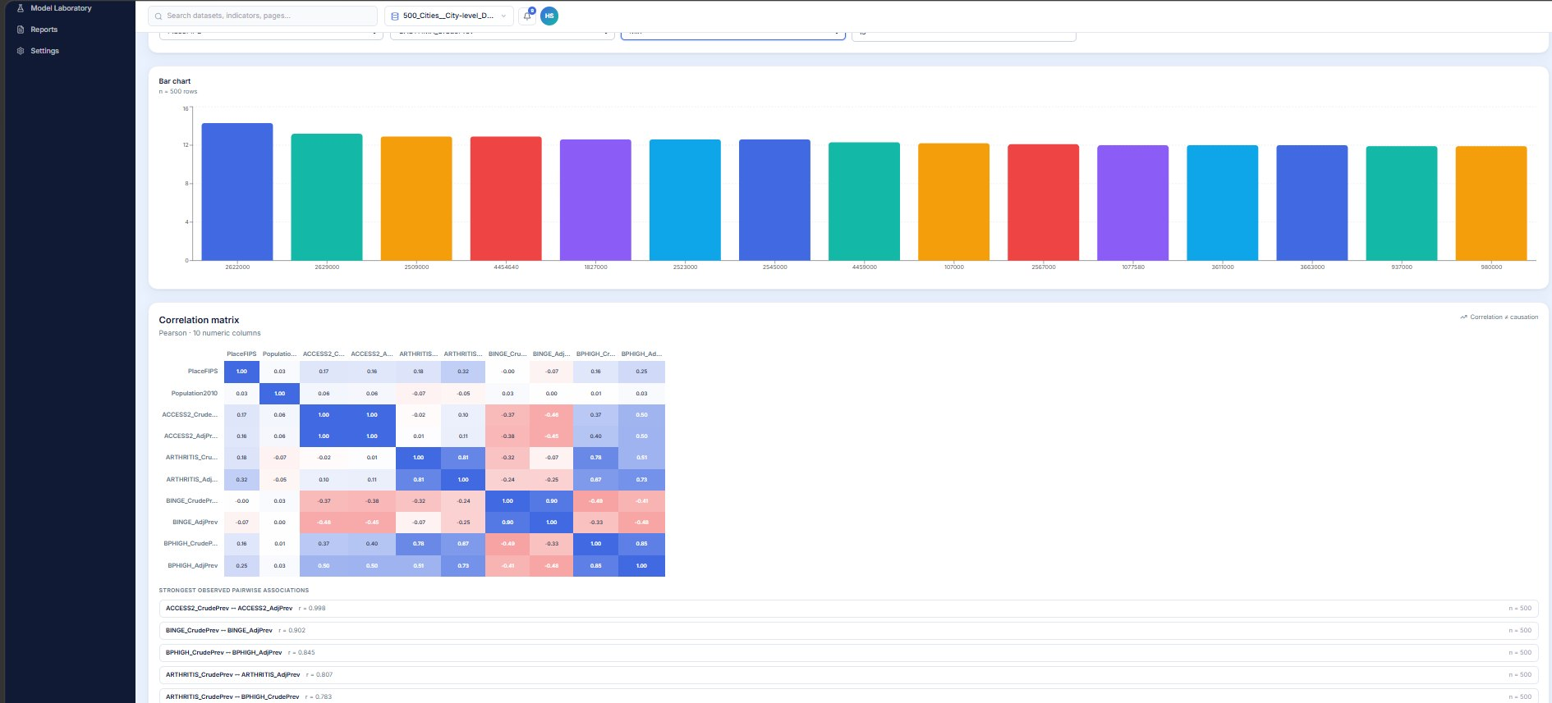
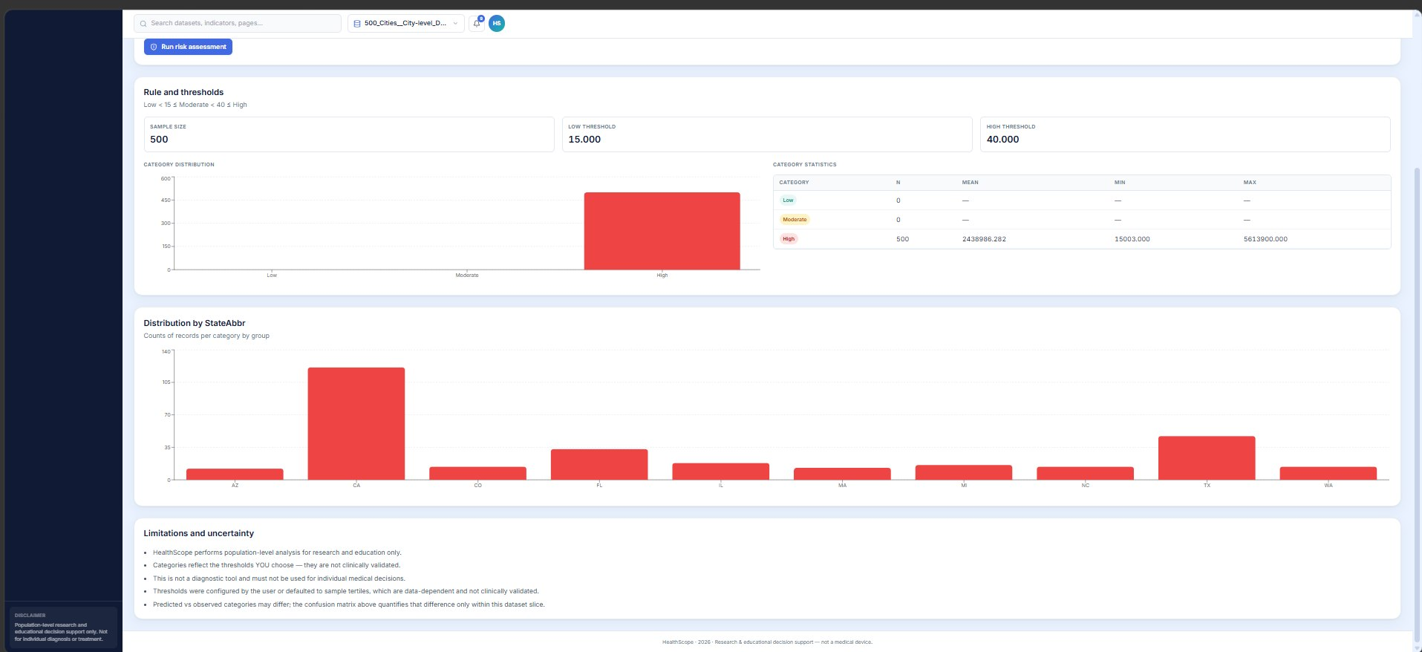
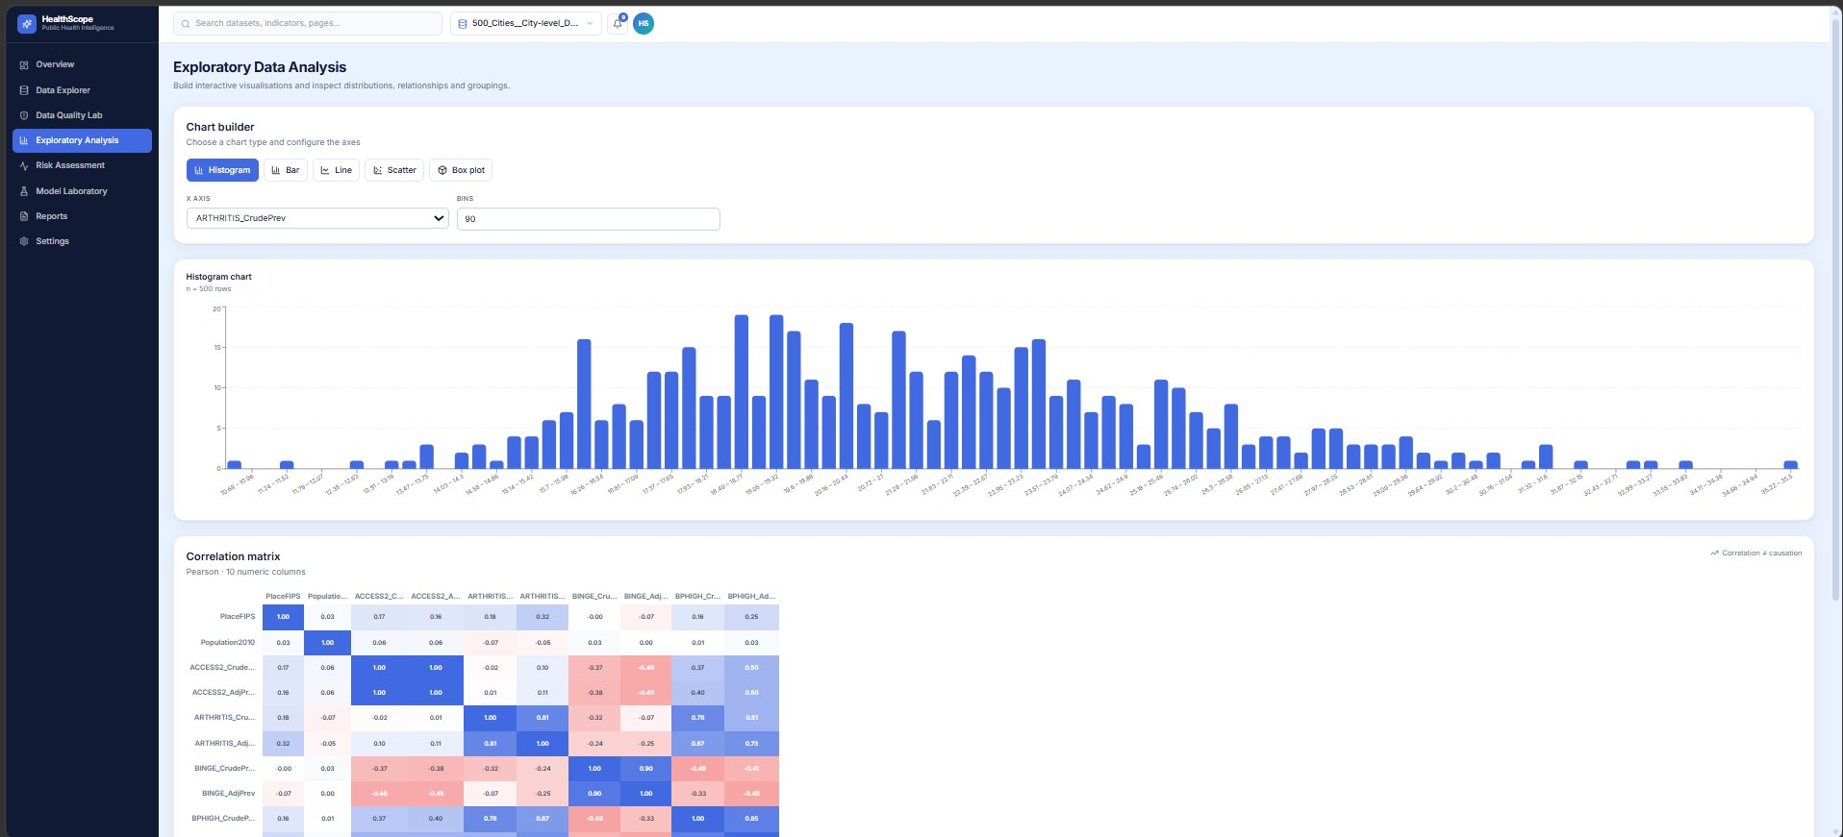
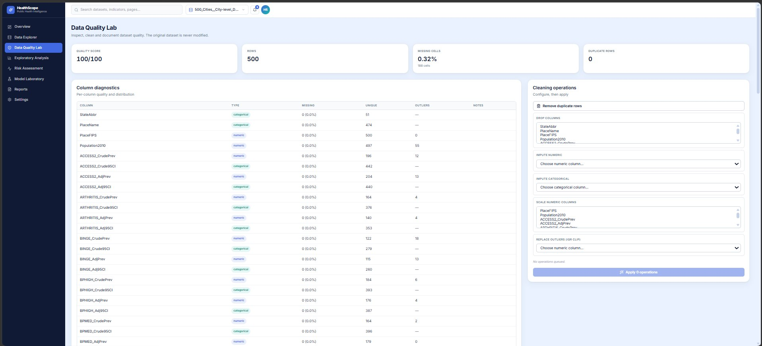

CHAPTER 6

Conclusion and Future Aspects

5.1 Conclusion
- HealthScope provides an integrated approach to public health data analysis and risk assessment.
- It combines data collection, preprocessing, exploratory data analysis and statistical analysis.
- Machine learning can be used to identify health-risk patterns when suitable data are available.
- Interactive dashboards help users understand health trends and compare population groups.
- The platform aims to make public health information easier to analyse and interpret.

5.2 Future Aspects
• More Datasets: Integrate additional health datasets from different regions and countries.
• Advanced Machine Learning: Explore improved prediction models and explainable AI techniques.
• Real-Time Updates: Include automatic data updates from reliable public health sources.
• Geographical Analysis: Add interactive maps to identify regional health patterns.
• Better Visualization: Develop more interactive dashboards with advanced charts and filters.
• Scalability: Deploy the platform online so that more users can access it.

CHAPTER 7
Bibliography

- https://www.cdc.gov/places/about/
- https://www.cdc.gov/places/methodology/index.html
- https://www.cdc.gov/places/tools/data-portal.html

